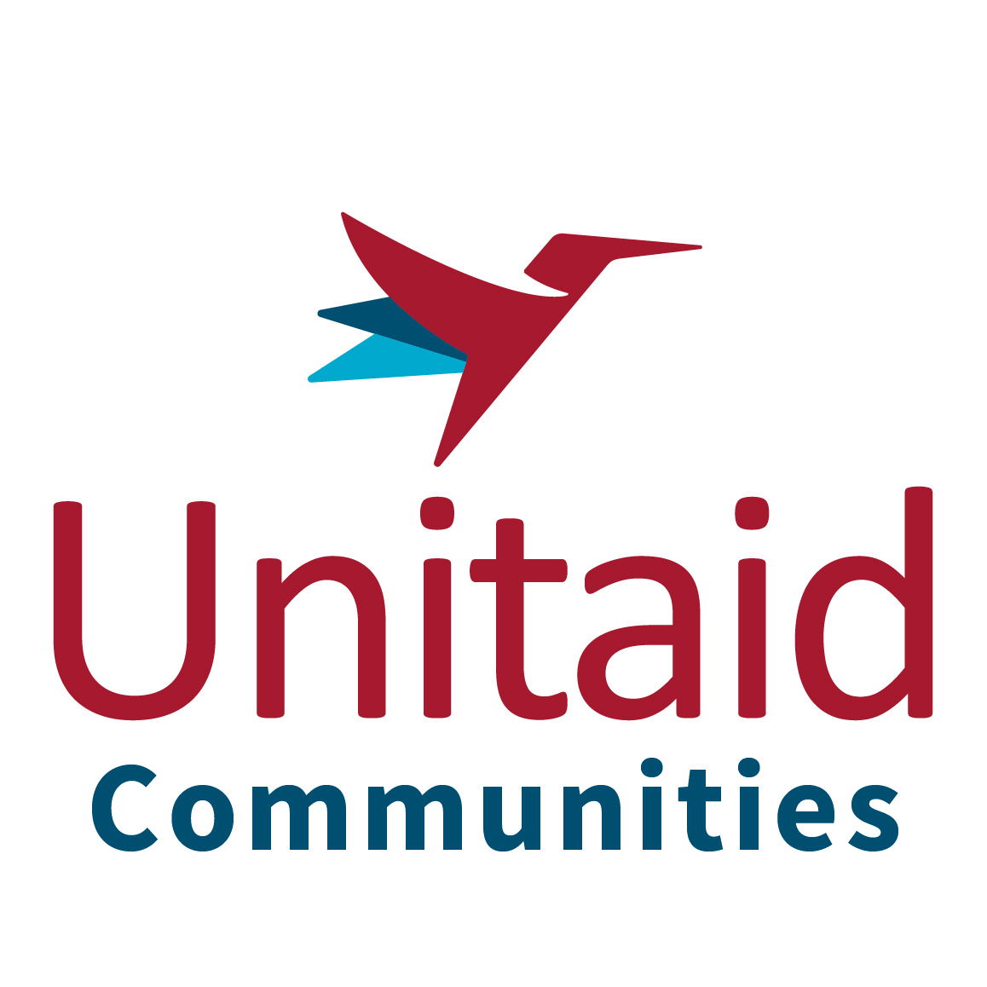

Membership of the Communities Delegation to the Unitaid Board

2023 Application Form

Personal details (according to passport)
Last Name
First, Middle Name
Title (Mr / Ms / Dr)
Date of Birth
Nationality
Country of residence
Home Address (street, city, county, zip code, country)
Email
Telephone nr (home) | +
Telephone nr (mobile) | +
Gender

Organisational details
CBO or NGO of affiliation
Address of organisation

Brief description of the organisation
Position held in organisation
Issues, diseases or populations on which your work focuses or serves (specify all that apply: PLHIV, TB, Malaria, Hepatitis, IP, RNMCH, etc)

Availability
There are normally two Unitaid Board meetings (2 days each), two pre-meetings (2-3 days each) per each year. They usually take place in Geneva but when there are travel restrictions, meetings are held virtually. If selected to attend one of these face-to-face meetings, will you be able to dedicate the necessary time to attending, travelling and preparing for 1-3 days beforehand? | Y/N
I declare that I have read and understood the Communities Delegation Member Terms of Reference, available at the end of this document. | Y/N
Would you be able to demonstrate active participation by reading, commenting and supporting advocacy on at least 25% of Committee/Board Meeting papers? | Y/N
Would you be able to dedicate a minimum of 5 hours per week on Unitaid-related work? | Y/N
Do you have your employer or organisation’s formal support for this time commitment, and have you attached a letter of assurance to confirm this availability? | Y/N

Are you living with, or survived one or more of the diseases Unitaid focuses in? Please list all applicable.
Please note that Delegation membership is only open to:
> PLHIV,
> people with personal disease experience with TB,
> for malaria, proof that members are directly linked to the affected communities, with active engagement at national and regional/global level,
> personal disease experience with HCV, cervical cancer and Chagas disease.

Knowledge, experience and skills
Please describe how you meet each of the following criteria. Please give examples in your answers.
Understanding of commodity procurement and supply issues in the fields of HIV, TB, Malaria, viral Hepatitis, cervical cancer or Reproductive, maternal, newborn and child health (RMNCH)
Knowledge of issues related to access to drugs and diagnostics in developing countries.
Understanding of intellectual property issues in relation to access to medicines (at country or international level)

Please describe your understanding of Unitaid’s Community Delegation and your vision for its future

Please describe your access priorities for one of the Unitaid priority disease areas (HIV, TB, malaria and/or HCV co-infection)

Applications without the requested information will be automatically disqualified. Please send this form along with the following two documents to wvandevelde@gnpplus.net by COB July 14 2023. Incomplete applications will not be considered.
- Short CV/resume (maximum 1 page)
- Signed letter of reference on headed paper from the organisation to which you are affiliated, agreeing to the 5 hours per week time commitment and occasional international travel involved (maximum 1 page)

UNITAID Communities Delegation Member
Terms of Reference
INTRODUCTION
This document outlines the role, terms of office, qualifications and commitments required to serve as a Member of the Communities Living with and Affected by HIV, TB and Malaria and those Co-infected with HIV and HCV Delegation to the Board of UNITAID.
The Communities Delegation has a maximum of 30 members (inclusive of the leadership) and will strive to achieve a minimum of 5 Delegates from the HIV community, 5 from malaria, 5 from tuberculosis, 5 from HIV/HCV co-infection and 10 from cross-cutting areas such as market dynamics, pricing, new drug product development, intellectual property etc.
SELECTION CRITERIA
Membership of the Communities Delegation is on an individual basis. To be eligible, the individual must meet the following criteria:
• A person: –
o Living with HIV; and/or
o Living with or had Tuberculosis; and/or
o Living with, or working with, communities affected by Malaria; and/or
o Living with or had HIV/HCV co-infection
• Be fully able to communicate orally and in writing in English (additional languages are valued)
• Demonstrated expertise and understanding of the scope of work of UNITAID and the opportunities it presents, particularly relating to issues of people living with and affected by HIV, tuberculosis, malaria and HIV/HCV co-infection at country level
• Particular expertise in issues such as HCV, market dynamics, pricing, new drug product development, intellectual property etc;
• Consistent internet, email and phone access;
• Demonstrated linkages with community networks (local, national and/or regional levels);
• Capacity to communicate and network effectively and broadly;
• Commitment to maintaining confidentiality around any confidential documentation available through UNITAID Committee and Board meetings
• Commitment to principles of transparency and accountability;
• Diplomatic and strategic political and negotiating skills to work with a variety of stakeholders;
• Openness, willingness and ability to learn, and the commitment to engage in issues of different constituencies;
• Commitment to a minimum of five hours per week for UNITAID related activities;
• If employed by an organisation, written assurance regarding the availability of five hours per week of time for UNITAID related activities; and
• A letter of institutional support from an employer or affiliated organisation.
• At least one of the Delegation Members should be under 25 years of age.
Desirable
• Be a national of and have lived and worked in an implementing country
• Gender balance and a geographical balance.
Wherever possible, there should be only 1 member per country and we strive to ensure a balance across Members coming from the HIV, TB, malaria and HIV/HCV co-infected communities
ROLE PROFILE
Members of the Communities Delegation are expected to work closely with the Board Member (BM), Alternate Board Member (ABM) and Community Liaison Officer, and will work primarily through email and conference calls. The primary role of all delegation members is to provide support and advice to the BM, ABM, and the Community Liaison Officer.
Members of the Communities Delegation have the following responsibilities:
• To uphold and support the mission of the Communities Delegation;
• Consult with communities, and communicate their priorities and needs linked to UNITAID;
• Meaningfully participate in all discussions of the Communities Delegation, especially related to Committee and Board Meetings of UNITAID;
• Respond to communications within the time frame requested noting that silence means approval where decisions are being made;
• Commit to a minimum of 5 hours a week for UNITAID related duties;
• Declare a conflict of interest; and
• Maintain Board and Committee documents confidential.
• Declare since the beginning of any potential conflict of interest that his membership at the delegation may have (refer to the delegation’s Conflict of Interest Management)
Orientation and training will be provided to new Communities Delegation Members at the start of each Board Meeting and through regular topic-specific briefings. This will be further developed throughout 2016.
Communities Delegation Members are eligible to apply for the position of (Alternate) Board Member based on the criteria for this position.
KEY PERFORMANCE INDICATORS
The following are Key Performance Indicators (KPIs) that Communities Delegation Members must commit to and achieve:
• A 50% response rate for requests for personal and substantive input and/or decision(s) between UNITAID Board Meetings;
• Active participation in the work of at least ONE committee of UNITAID that the Communities Delegation is represented on where nominated;
• Demonstrated active participation by reading, commenting and supporting advocacy on at least 25% of Committee/Board Meeting papers;
• Communicate and consult with between 5 and 10 global, regional and national contacts on key issues; and
• Participate, when selected, in two-day Board meetings that take place twice-yearly including two-three day pre-meetings.
The Communities Delegation Member may be requested to attend country-level/regional consultations, occasional additional Board ‘special sessions’, retreats, workshops, consultative fora and teleconferences.
All Delegation Members will be required to sign and return a statement confirming their understanding of the KPIs and their commitment to achieve them.
SELECTION PROCESS FOR COMMUNITIES DELEGATION MEMBERS
The Community Liaison Officer issues an open call requesting applications to the Communities Delegation at least once every two years. The call will ask interested applicants to answer three questions about UNITAID, the role of the Communities Delegation and for some information about priorities in one of the three disease areas. A Selection Panel consisting of the BM, ABM, Community Liaison Officer and two members of the current Delegation will be set up, and applicants are selected according to predefined criteria set out above together with an assessment in relation to the written responses received. A short list of applicants will be compiled and each prospective member will be required to take part in a 15 minutes telephone call where they will have a chance to share their understanding and particular area of interest in relation to UNITAIDs’ core business.
Applications will be treated in a confidential manner. The Selection Panel makes the final decision with the outcome shared through various list-serves and platforms by the Community Liaison Officer.
COMMUNITIES DELEGATION SELECTION PROCESS FOR ATTENDANCE AT PRE-BOARD AND BOARD MEETINGS
Being a Delegation Member does not necessarily mean attending meetings.
A number of Communities Delegation members are selected before each UNITAID Board meeting, to receive funding and logistical support to attend UNITAID Communities Delegation’ pre-Board meetings, and where possible, observe at the Board meetings themselves. The number of delegation members invited is dependent on funding (though some attendees/those who are based in the meeting location will be self-funded).
The selection process for pre-Board and other Communities Delegations’ meetings is as follows:
1. The Board and Alternate Board Members will specially invite Members to attend a Board meeting based on the needs of the particular meeting.
2. At least two diseases will be represented in the individuals selected to attend.
3. Every effort will be given to rotate these opportunities.
DURATION OF TERM
Members of the Communities Delegation serve a three-year term. Dependent on performance-based assessment, a two-year extension of this term may be granted by the leadership. However, at the end of the three year term, at least 50% of delegation members should be rotated off.
FINANCIAL SUPPORT
The roles of Communities Delegation Member is voluntary and hence there is no payment for the work. Travel and per diem costs are covered by the UNITAID Secretariat or the Communities Delegation.
CESSATION
A Communities Delegation Member will cease to be a member if:
• He/she resigns;
• He/she no longer has an employer who is supportive of the 5 hours time commitment required
• The outcomes of his/her annual evaluation in his/her role as Delegation member are deemed cause for a resignation by evaluation panel;
• If a conflict of interest is declared and it is not possible to work around this
• When his/her term is completed
After having served the full term, Delegation Members are required to have at least a one-year break before reapplying. Applicants will then undergo the standard selection process.

